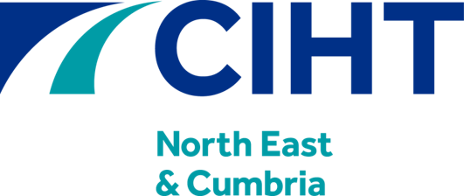

Annual Awards 2024
Highways and Transportation
Sustainability Project of the Year Award
Entry Form
Closing Date for Entries: 19 July 2024

Award Presentation: 26 September 2024

www.ciht.org.uk/neandc
North East & Cumbria Region Annual Awards 2024
Highways and Transportation Sustainability Project of the Year – Entry Form

The CIHT North East & Cumbria Region Annual Awards celebrate the very best that the region can offer across all areas of highways and transportation. The awards are open to everyone: members and non-members; small and large companies; public and private sector. The awards recognise the outstanding contribution the CIHT Region makes to all our lives.
The Sustainability Project of the Year Award is to recognise and encourage an environmentally sustainable approach to imaginative research, concepts and excellence within the highways and transportation industry where a marked positive benefit has been achieved in the North East & Cumbria or been produced by people working in the area.
It can relate to design, construction, management, product development or any other facet of the industry and includes projects of any size.
Project Title
Project Details | Location
 | Sector/Area
 | Client
 | Aim of the Project
Companies
Involved
Submitter’s Details | Name
 | Position
 | Organisation
 | Address
 | Email

North East & Cumbria Region Annual Awards 2024
Highways and Transportation Sustainability Project of the Year – Entry Form
Why is your project deserving of the Sustainability Project of the Year Award?
(maximum 500 words – Supporting images / pictures / plans can be attached to this submission)
Consider: Enterprise and ingenuity in the current climate crisis; A project that has overcome challenges to continue operation and/or implementation; Performance measures; Wider implementation potential; Benefit to the innovator, and; Cost benefit (if applicable). The submission will be judged against the following criteria (equal weighting to all categories) – innovation, sustainability and environmental considerations, social and local community benefits and cost effectiveness.
North East & Cumbria Region Annual Awards 2024
Highways and Transportation Sustainability Project of the Year – Entry Form

Do you have an independent endorsement? (maximum 100 words)
For example, an endorsement can be from a client who can provide an additional professional recommendation for the candidate over and above the submitter.
Please provide the endorsement below, as well as the details of the endorser.
Submitter’s  signature |  | Date
I agree to the General Guidelines and Data Protection Notices posted on the CIHT region website
I am submitting additional supporting information

Awards entries can be submitted until 19 July 2024 by emailing them to regions@ciht.org.uk under the subject header of ‘CIHT North East & Cumbria Awards 2024’.
The award winners will be announced on 26 September 2024 at the Annual Awards Dinner at the Crowne Plaza Hotel, Newcastle.
All entries will be listed on the CIHT website and email newsletter.
Thank you for your entry and involvement with the CIHT!

